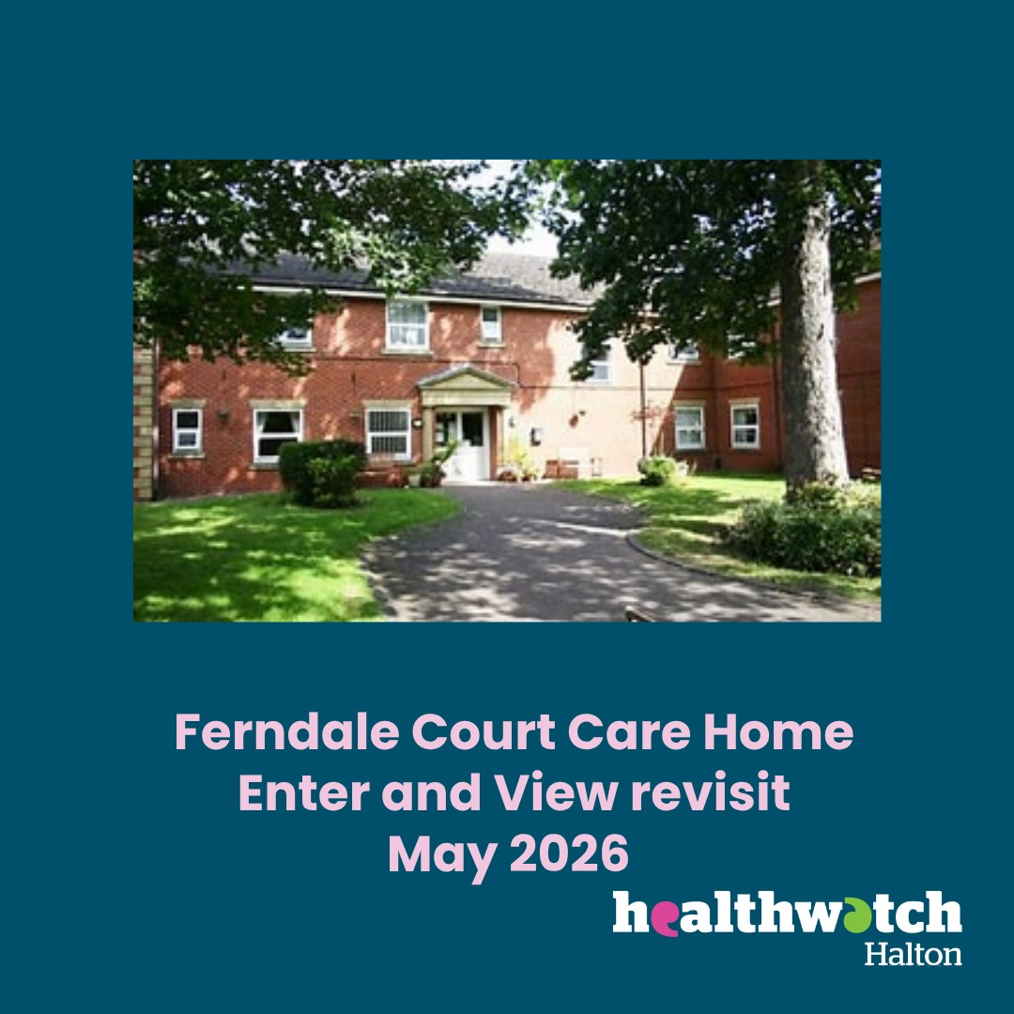

Enter and View Revisit Report
Ferndale Court Care Home
Announced visit
13th May 2026

Provider details
Details of Visit | Ferndale Court Care Home. Enter and View revisit
Registered Manager | Mr Ristner Calagui Yarcia
Service Address | St. Michaels Road, Widnes. WA8 8TD.
Service type | Nursing, residential and dementia care.
Date and Time | 13th May 2026  10 am – 12 noon
Authorised Representatives undertaking the visit | Tracy Cresswell and Jude Burrows

Acknowledgements
Healthwatch Halton would like to thank the Home Manager, staff and all the residents and visitors for their cooperation during our visit.
Disclaimer
Please note that this report is related to findings and observations made during our visit on the 13th May. The report does not claim to represent the views of all service users, only those who contributed during the visit.
Who we share the report with
This report and its findings will be shared with the Manager of Ferndale Court, Care Quality Commission (CQC) and Healthwatch England. The report will also be published on the Healthwatch Halton website.
Healthwatch Halton details
Website: www.healthwatchhalton.co.uk
Telephone: 0300 777 6543
Email: enquiries@healthwatchhalton.co.uk
Purpose of the visit

The visit was an announced follow-up visit on the recommendations that were made on our initial visit in January 2024.

What we did
We revisited Ferndale Court Care home, with the initial full Enter and View visit previously taking place in January 2024. Since then, the home has been sold to a new provider and has a new manager in post since November 2024. Landona now runs the home.
We arrived at the care home and were able to park easily in the home's car park. We rang the bell at the main entrance and were welcomed in promptly. We were asked to sign in to the visitors' book. The manager then greeted us and invited us into one of the lounge areas. We spent time talking to the Manager and were taken on a tour of the home.
The home has a Care Quality Commission (CQC) rating of Good, with Requires Improvement for caring. The certificate is displayed in the main entrance.
Hand sanitiser was available in different areas around the home.
A new sensory room has recently been introduced in the home’s conservatory. The room has relaxing lighting and decorative features. During our visit, residents were supported to use it to wait for the weekly hairdresser visit. The area has been named ‘The Happy Place’ following ideas collected from residents and families.
A residents' meeting took place on the day before our meeting and was promoted with posters displayed around the different areas of the home and on the main entrance door.
The manager explained that he holds a “manager's surgery” in the lounge every Wednesday for staff to drop in, he explained that it was less formal for the staff, as if it were in the office the staff felt like they were in trouble.
The home is now run digitally, rather than paper based, with online records now in place. The manager explained that this has made the home more efficient. Verbal staff handovers still take place between shifts. This change does mean the care staff can be seen on mobile devices, but the change was explained to residents and families, so they are aware that staff are working and not on their personal mobile phones.
Bank staff support the home via 2 x 20-hour posts. Internal, word-of-mouth recruitment takes place for any vacant posts.
Two vacant beds were available in the home on the day we visited.
Beeches Medical Centre is the GP for Ferndale Court, and a doctor visits the home on Monday each week. The manager explained he has had no issues with hospital discharges at unsociable hours but does sometimes have to chase prescriptions up from Warrington Hospital.
The home has recently received a 5-star food hygiene certificate.
The residents we observed during our visit looked happy. Several were waiting for their weekly hairdresser visit, some were watching TV in their bedrooms, and another resident was pushing a pram in the dementia area of the home.
Ferndale Court has an Activity Coordinator and a Maintenance Officer employed, as well as care staff. Private contractors are currently also supporting the refurbishment of the home. The manager explained that the Nursing floor had had corridors, rails, and skirting boards repainted and it had been completed by the maintenance officer. The dementia unit will be completed by the contractors, and the manager had indicated that would be done in 6 months time, and once the dementia unit had been refurbished the residential unit would then be completed.
Signage around the home is inconsistent, with some dementia friendly pictorial signs used, some black and white signs and certain areas, such as the upstairs lounge, having no signs at all.
We shared information on a dementia friendly radio station that may be useful to play to residents. About | Support Dementia Awareness — Join Us Now — Merseyside Dementia Friendly Radio.
We also offered to promote fundraising events via our social media channels.
Outcome of Recommendations made at previous visit (2024)
Recommendations made from findings
1 | Ensure that all areas are maintained and decorated to give a bright and warm feeling to the area, including the furniture.
Since our last visit the Nursing area of the home has been redecorated by the home's Maintenance Officer. The Dementia area will be decorated by contractors in the near future, and the residential area will also be redecorated. Carpets in the dementia area of the home have been replaced with new laminate flooring.

Consider redecorating the painting of a vending machine with drinks in that is currently on the dementia area wall, as this could be confusing for residents with dementia.
2 | Look into options for all staff to take part in the Oliver McGowan mandatory training on learning disability and Autism.
 | Oliver McGowen training is now included in the care staff's mandatory training. Two weeks are given to complete all mandatory training for new starters.
3 | Ensure that Dementia Friendly signage is used in appropriate areas and ensure that, where necessary all the toilets have a contrasting colour seat.
Eye Care has supplied signage for the home and pictorial menu boards for dining rooms. Demetia signage still varies around the home, with some doors having clear, appropriate signage and others having less clear and differing or no signage.

Only one toilet seat was a contrasting blue colour. The home was unaware of this good practice for people with dementia and will look into primary coloured contrasting seats for all toilets. Also consider contrasting-coloured doors on toilets to enhance the dementia-friendly environment.
4 | Ensure that all visitors, relatives and residents know who the staff are by the staff always wearing a name badge and having photos of uniform and what roles they represent on a notice board.  a) Consider having name badges for staff in the format of “My name is” dementia friendly yellow badges.
Staff were not wearing name badges during our visit. There was no notice board to display staff roles.

The manager should consider purchasing all staff clear name badges and consider installing a notice board with photos of uniforms and the roles of staff.
5 | Consider using photo frames for residents' doors with their name, photo and a personal picture of their choice.
Some residents' doors displayed residents name and something they like to do or enjoy, such as watching films. These were displayed on laminated print outs which were not very clear. The manager explained they work with families and residents to choose what goes on each bedroom door and it is a personal choice.
Continue to ensure all residents are offered door sign choices and make sure signs are clear and dementia friendly.
6 | Consider ensuring that all communal areas and facilities have pictorial signs on them.
 | The dining areas have pictorial menu boards displayed, showing the date and pictures of each course. Add pictorial signs to all doors that residents use, such as lounges and dining areas.
7 | Ensure that details of activities are displayed in all lounge areas.
 | A pictorial activities timetable was displayed on an easel at the main entrance, in the sensory room and upstairs on the wall.
8 | At residents’ meetings, consider discussing the different activities that residents would like to be involved in; this could include going for a walk outside of the home as part of their daily exercise.
Family and friends are asked for ideas at the residents' meetings. The home also does ‘Resident of the Day’ where staff discuss a resident's needs and likes to ensure person-centred care.
The home can access a minibus that is shared with another home, which is also run by Londana, but are having difficulty finding a driver.
Healthwatch suggested contacting Halton Community Transport to see if they can offer transport for residents' trips out.
9 | Look to introduce a ‘You said, We Did’ board to highlight for residents and relatives any changes that have been made from comments, complaints, etc. but also try to explain if you are unable to do it and why.
 | The home still does not have a ‘You Said We Did’ board displayed. The manager explained that they do have a file with feedback and actions taken. We explained that having a “You Said, We Did, board was a way of showing the residents, relatives and staff that they are being listened to. Consider having a ‘You Said We Did’ notice board put up for residents and visitors to view.
10 | Ensure that all the pull cords in the toilets are not tied up so residents are unable to reach them.
 | In the bathrooms we viewed on the day, all pull cords were untied and reaching to the floor, during our visit.
11 | Ensure that the car park spaces are well maintained and kept clear of mud.
 | The car park was maintained to a good standard and clear on the day of our visit.
12 | Ensure that information on Healthwatch Halton Advocacy Hub service is clearly displayed for staff, residents, visitors and relatives.
 | We still did not see this information displayed. We left general Healthwatch Halton leaflets with the manager to display.

Provider feedback
Thank you for taking the time to visit our home and for providing your feedback and recommendations. We appreciate the constructive observations made and the opportunity to reflect on areas where further improvements can be considered.
We would like to note that we did not have sight of the report from your previous visit, which took place while the home was under previous management, until it was sent to us when confirming the date for the revisit. As a result, we were not aware of the specific findings and recommendations identified during that inspection. However, since Landona House Ltd took over the management of the service, we have already commenced a comprehensive programme of improvements across the home. These improvements have focused on enhancing the environment, strengthening person-centred care, improving communication, and promoting positive outcomes for residents.
We are encouraged that a number of the areas highlighted during your recent visit were observed to be in place or had already been addressed. For example, the Nursing Unit has been redecorated, new flooring has been installed within the dementia area, emergency pull cords were observed to be accessible, the car park was maintained to a good standard, In addition, the Oliver McGowan Mandatory Training has been incorporated into mandatory training requirements for care staff, and "My Name Is" badges have already been ordered.
We have carefully considered all of the recommendations made and have provided our responses accordingly. Where improvements have already been implemented, we have outlined the actions taken. Where recommendations require further review, we have committed to exploring these as part of our ongoing quality improvement programme, taking into account the individual needs, wishes, and preferences of our residents.
Please be assured that continuous improvement remains a key priority for the home. We are committed to maintaining a safe, welcoming, and person-centred environment and will continue to review our practices, seek feedback from residents and their families, and implement changes that enhance the quality of care and the overall experience of those living in the home.
Responses to the Recommendations:
- We are pleased that the recent redecoration of the Nursing area has been acknowledged. As noted, further refurbishment works are planned, with contractors/maintenance Officer scheduled to redecorate the Dementia area in the near future, followed by the Residential area. In addition, the carpets in the Dementia area have been replaced with new laminate flooring to improve the environment for residents.
We appreciate your feedback regarding the wall painting depicting a drinks vending machine in the Dementia area. We recognise that visual images can sometimes be misinterpreted by people living with dementia and may cause confusion or unnecessary frustration. We will review the suitability of this artwork as part of the planned redecoration works and consider replacing it with imagery that is more appropriate and supportive for residents living with dementia.
- We can confirm that the Oliver McGowan training is incorporated into the mandatory training programme for all care staff. New starters are allocated two weeks to complete all mandatory training requirements, including the Oliver McGowan training, as part of their induction process.
This approach helps ensure that staff have the knowledge and understanding required to support people with learning disabilities and autistic people in a safe, effective, and person-centred manner. We will continue to monitor training compliance and ensure staff remain up to date with mandatory learning requirements.
- Thank you for your observations and recommendations regarding dementia-friendly signage and the use of contrasting colours within the home.
We welcome the feedback and can confirm that Eye Care has supplied signage for the home, including pictorial menu boards for the dining rooms. We acknowledge that dementia-friendly signage currently varies throughout the home, with some areas having clear and appropriate signage while others would benefit from greater consistency. We will review the signage across all areas and consider opportunities to improve consistency and clarity where appropriate.
With regard to contrasting-coloured toilet seats, we note your recommendation and appreciate the information provided on recognised dementia-friendly design principles. At present, only one toilet has a contrasting blue seat. As our EMI unit supports residents with lower-level dementia needs, we do not automatically assume that residents are unable to identify toilet facilities independently. Ongoing supervision, observation, and monitoring of residents form part of our individualised risk assessment process, and we implement appropriate interventions when a specific need or risk has been identified.
That said, we value the recommendation and will explore the potential benefits of introducing primary-coloured contrasting toilet seats and, where appropriate, contrasting toilet door colours as part of our ongoing environmental reviews. Any changes will be considered alongside the individual needs of our residents to ensure the environment remains supportive, safe, and person-centred.
Thank you for highlighting these considerations. We are committed to continually reviewing and improving the home environment to support the wellbeing and independence of our residents.
- Thank you for your recommendation regarding staff identification and supporting residents, relatives, and visitors to recognise staff roles more easily.
We agree that clear staff identification is important in promoting effective communication, reassurance, and a dementia-friendly environment. All staff are expected to wear name badges while on duty, and we will continue to reinforce this expectation.
In response to your specific recommendation, we have already placed an order for badges, which are currently awaited for delivery. Once received, these will be issued to staff to improve visibility and support easier identification for residents, relatives, and visitors.
We will also consider the use of a staff notice board displaying photographs, uniforms, and job roles to further enhance awareness of the different members of the team and their responsibilities within the home.
Thank you for this valuable suggestion, which supports our ongoing commitment to providing a welcoming, person-centred, and dementia-friendly environment.
- Thank you for your recommendation regarding residents’ bedroom door signage.
We recognise the importance of personalised and dementia-friendly door signs in supporting residents’ independence, orientation, and sense of identity. As noted, some residents currently have personalised displays on their bedroom doors, including their name and information about their interests or hobbies. These are developed in partnership with residents and their families, ensuring that the content reflects individual preferences and remains a personal choice.
We acknowledge the observation that some of the laminated displays were not as clear as they could be. We will continue to review the presentation of bedroom door signage to ensure it is clear, visible, and as dementia-friendly as possible. This will include considering the use of photo frames and other display formats where appropriate and in line with residents’ wishes.
We will continue to offer all residents and their families choices regarding bedroom door signage and work collaboratively with them to create personalised displays that support recognition, promote independence, and reflect the individual’s preferences and identity.
- Thank you for your recommendation regarding the use of pictorial signage throughout the home.
We are pleased that the pictorial menu boards displayed in the dining areas have been recognised. These provide residents with clear visual information about the day's meals and support choice and independence.
We acknowledge the recommendation to extend the use of pictorial signage to other communal areas and facilities used by residents, such as lounges, dining rooms, and other key areas within the home. We recognise that clear, consistent pictorial signage can support orientation, wayfinding, and independence, particularly for residents living with dementia.
As part of our ongoing review of the home's environment, we will assess current signage and consider introducing additional pictorial signs to resident-accessible areas where appropriate. This will help promote a more dementia-friendly environment while supporting residents to navigate the home with greater confidence
- Thank you for your recommendation regarding the display of activities information throughout the home.
We can confirm that a pictorial activities timetable is currently displayed at several key locations within the home, including on an easel in the main entrance area, within the sensory room, and on the upstairs notice board. These displays are intended to keep residents, relatives, and visitors informed about upcoming activities and events.
We acknowledge the recommendation to ensure that details of activities are displayed in all lounge areas. We recognise that having activity information readily available in communal spaces can further encourage participation, support choice, and help residents remain engaged in the life of the home.
- Thank you for your recommendation regarding resident involvement in planning activities and opportunities for outings within the community.
We can confirm that residents, family members, and friends are regularly encouraged to share ideas and suggestions during residents’ meetings to help shape the activities programme. In addition, the home operates a “Resident of the Day” initiative, during which staff discuss each resident’s individual needs, preferences, interests, and goals to help ensure care and activities remain person-centred.
We recognise the importance of involving residents in decisions about the activities they would like to participate in, including opportunities for walks outdoors and other forms of exercise that promote wellbeing and independence. We will continue to encourage these discussions during residents’ and relatives’ meetings and through individual care planning and reviews.
The home also has access to a minibus shared with another Landona home, with a driver available when required, enabling residents to participate in outings and community-based activities. We appreciate the suggestion from Healthwatch regarding Halton Community Transport and will explore whether their services could provide additional opportunities and flexibility for resident trips and excursions.
- Thank you for your recommendation regarding the introduction of a “You Said, We Did” board.
We recognise the value of clearly demonstrating to residents, relatives, visitors, and staff that feedback is listened to and acted upon. Whilst the home currently maintains a record of feedback received and the actions taken in response, we acknowledge that this information is not as visible or accessible as it could be.
We appreciate the suggestion and agree that a “You Said, We Did” board could provide a simple and effective way of sharing improvements made as a result of comments, suggestions, compliments, and complaints. It would also provide an opportunity to explain where a suggestion cannot be implemented and the reasons for this, helping to promote openness and transparency.
We will therefore consider introducing a “You Said, We Did” notice board in a prominent area of the home so that residents, relatives, visitors, and staff can easily view how feedback contributes to ongoing service improvements.
Thank you for this constructive recommendation. We are committed to encouraging feedback and ensuring that those who use and visit the service can see the positive impact their views have on the continual development of the home.
- We can confirm that, during your visit, all emergency pull cords observed in the bathrooms were untied and extended to floor level, ensuring they were accessible to residents should assistance be required.
The home recognises the importance of maintaining emergency call systems in accordance with good practice and will continue to monitor this through regular environmental checks and audits. Staff will also remain vigilant in ensuring that pull cords are not tied up or obstructed and remain readily accessible at all times.
- We are pleased that the car park was observed to be maintained to a good standard and clear of mud on the day of your visit. Maintaining safe and accessible external areas is an important part of our commitment to providing a welcoming environment for residents, visitors, and staff.
As part of the home's daily management walkaround, the outdoor grounds, including the car park, are routinely checked to ensure they remain well maintained, clean, tidy, and free from potential hazards. Any issues identified are addressed promptly through the home's maintenance procedures.
We will continue to monitor and maintain all outdoor areas to ensure they remain safe, presentable, and accessible throughout the year.
- Thank you for your recommendation regarding the display of information about the Healthwatch Halton Advocacy Hub service.
We acknowledge that this information was not visible prior to your visit. However, once the Healthwatch Halton leaflets were provided on the day, they were displayed immediately in a prominent location within the home. The leaflets have remained on display since then and continue to be accessible to residents, relatives, visitors, and staff.
We recognise the importance of ensuring that information about advocacy and support services is readily available to everyone who uses or visits the service. We will continue to monitor our information displays to ensure that relevant leaflets and resources remain visible, up to date, and easily accessible

