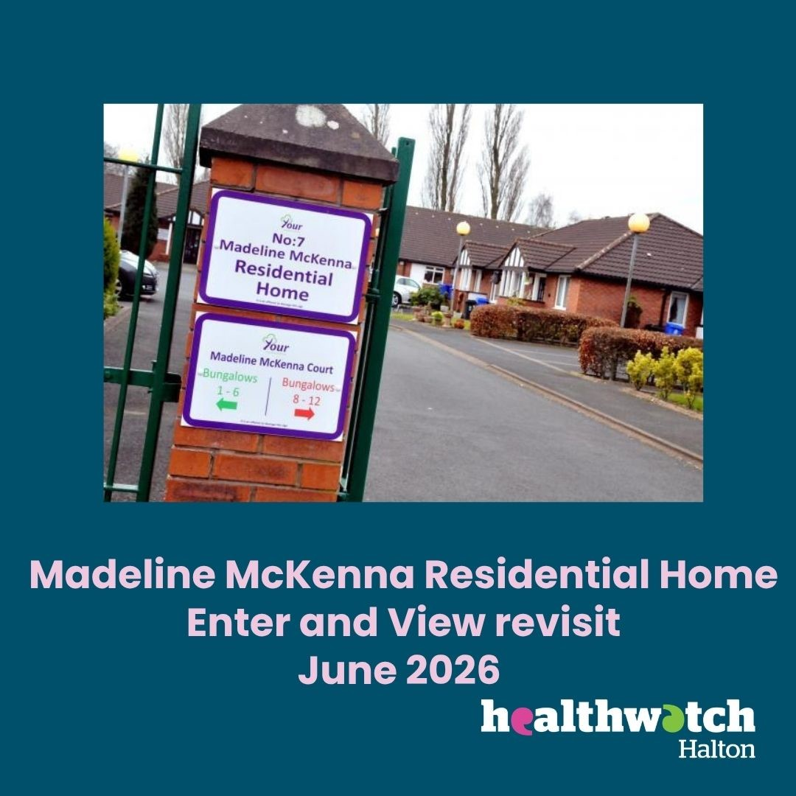

Enter and View Revisit Report
Madeline McKenna Home
Announced visit
4th June 2026

Provider details
Details of Visit | Millbrow Nursing Home. Enter and View revisit
Registered Manager | Claire Jones
Service Address | Madeline McKenna Care Home, Caxton Close, Widnes. WA8 4DW.
Service type | Residential and dementia care.
Date and Time | 4th June 2026  10 am – 11.30 am
Authorised Representatives undertaking the visit | Tracy Cresswell and Jude Burrows

Acknowledgements
Healthwatch Halton would like to thank the Home Manager, staff and all the residents and visitors for their cooperation during our visit.
Disclaimer
Please note that this report is related to findings and observations made during our visit on the 4th June. The report does not claim to represent the views of all service users, only those who contributed during the visit.
Who we share the report with
This report and its findings will be shared with the Manager of Madeline McKenna Care Home, Care Quality Commission (CQC) and Healthwatch England. The report will also be published on the Healthwatch Halton website.
Healthwatch Halton details
Website: www.healthwatchhalton.co.uk
Telephone: 0300 777 6543
Email: enquiries@healthwatchhalton.co.uk

Purpose of the visit

The visit was an announced follow-up visit on the recommendations that were made on our initial visit in January 2024.

What we did
We revisited Madeline McKenna Care Home, with the initial full Enter and View visit previously taking place in January 2024. The home is run by Halton Borough Council.
We arrived at the care home and were able to park easily in the home’s car park. We rang the bell at the main entrance and were welcomed into the porch area by the Admin Officer. We were asked to sign in to the visitors' book. Hand gel was available. The Manager greeted us and invited us into her office. We spent time talking to the Manager and were taken on a tour of the home. The home has 23 bedrooms and was at capacity, with a waiting list in operation, at the time of our visit. Assessments are done for people on the waiting list so they are ready when a place becomes available. Three places have already been given out to people on the list.
The Manager of the home has changed since our previous visit and has been in post since November 2025. She was very positive about her role and the care home in general. The home is fully staffed with care staff and employs an Activity Coordinator who does activities such as bingo, board games and crafts. She explained how she adapts games to suit the needs of each resident. No activity timetables were displayed in the home. A hairdresser visits the home each Monday.
The home's gardens are maintained by council workers and a Maintenance Officer, who will attend this care home once a week, is currently being recruited.
When new residents are placed at Madeline McKenna Care Home, an assessment is done to discuss the residents' needs, likes and dislikes. Families are also involved in this process. Residents are encouraged to use the communal areas of the home for meals and activities.
Staff wore different coloured uniforms to represent their different roles. A display board had photographs of the different staff roles. The Activity Coordinator wore lilac but was wearing blue on the display board. The home should consider updating this photo. The staff did not have name badges and explained that the magnetic name badges they had previously were not suitable as they often fell off when delivering care to residents. The manager told us that council lanyards are on order for staff and she wore a lanyard herself.
The home has a Care Quality Commission (CQC) rating of good. The home also has a five-star food hygiene status.
The home has recently achieved its Veteran Friendly status, and a poster was displayed on the main entrance to show this. A plaque has been ordered and will be hung up to show their status. Poppy symbols have been put on residents' doors and care plans to show they are a veteran or a family member of a veteran. This current applies to five residents at the home.
Hough Green Medical Centre is the GP for Madeline McKenna Care Home and a doctor visits the home on Tuesday each week. The manager told us she has had no issues with hospital discharges. We explained that we can raise any future issues at local trust patient experience meetings if needed. We also offered to promote events or fundraisers for the home via our social media channels or ebulletin.
Food is cooked on site with a TV in the dining area displaying food choices for the day. During our visit the TV display looked unclear and only mentioned the soup of the day. A poster on the wall listed supper choices such as toast or tea cakes. A pictorial menu displaying all meals for the day could be considered. Each dining table had a floral display, and a staff member was McKennalaying the tables ready for lunch during our visit.
The residents we observed during our visit looked comfortable, happy and well cared for. Some sat in the lounge watching TV, whilst others sat in the dining area or in their bedrooms. A selection of juice was available in the lounge, and hot drinks were being offered to residents during our visit. Separate, small sitting areas with TVs or books were available off the home's corridors.
Bedroom doors were all white, numbered and displayed a red, amber or green tab to show how much assistance would be needed in the case of an emergency, such as a fire. Some of these tabs were missing as they had been removed when the poppy symbols were added. The manager was made aware of this during our visit. Walls were also white with wooden handrails.
Toilets and shower areas had dementia friendly stickers on the doors and toilet seats were red to aid orientation for people with dementia.
Bedrooms were decorated to the residents' taste. We viewed one bedroom that had been nicely decorated by family members and was clean and bright.
The home has a garden with a patio and grassed areas. The garden is not fenced off and joins the car park area. The manager explained that residents are always accompanied by staff or visitors when they do go outside.

Outcome of Recommendations made at previous visit (2024)
Recommendations made from findings
1 | Activities: Several residents and family members expressed a desire for more activities at the home. It is recommended that the home recruit an Activities Co-ordinator as soon as possible to help provide a wider range of activities for the residents.
 | The home now has a part-time Activity Coordinator in place, who has worked at the home for 18 months, and who puts on regular activities for residents. The Activity Coordinator asks for residents' ideas of what sessions to deliver, invites schools, singers and baby groups into the home to meet with and entertain residents. Is also planning an animal visit for residents in the near future. Consider having a pictorial timetable displayed in the future.
2 | Dementia friendly: During any planned redecoration or renovations, consider making dementia friendly changes to the environment.
The home has dementia friendly signs on toilets and bathrooms. Has red toilet seats to aid orientation.
The bedroom doors are not painted in primary colours or photographs on doors. Consider using primary colours for handrails and doors to make them clearer and more dementia friendly.
Pictorial menus and activity timetables would provide useful information for residents and their visitors.
Consider adding photographs to bedroom doors to suit each resident and family's choices.
Ensure that the support that the residents required during a fire are displayed clearly on the residents door.

3 | Communication and Information: We heard from some families that there was sometimes a lack of communication with them by the home. Effective communication is essential in building trust and keeping families informed and involved in the care of their loved ones. We suggest providing regular updates, scheduling face-to-face meetings, and encouraging family involvement in the home. We recommend the introduction of a ‘You said, we did’ board for, and regular updates for relatives that would include any changes that have been made from comments, complaints etc.
Suggestion forms are available in the foyer of the home. No family meetings currently take place, but the home does have an open-door policy for questions and ideas. It was suggested that maybe renaming the meetings to coffee mornings more relatives may attend, to be discussed with the relatives and consider asking them to lead the sessions.

We suggest displaying a ‘You said We did’ board to show how residents and family’s ideas are listened to and actioned when possible. The idea of a newsletter is also being looked at.
Ensure that all staff are wearing their name badges when they are purchased.
Consider updating the information board that displays the staff roles and uniforms.

4 | Involvement: Some residents felt that they have not had the opportunity to be involved in residents' meetings. We suggest reviewing the way residents’ meetings are promoted to encourage more involvement and look at the options to hold more than two meetings per year.
 | Resident meetings now take place every six weeks. The last meeting saw 15 residents in attendance. The manager tells us that all residents are asked for their ideas. The residents had requested more exercise activities.
5 | Staffing: To ensure the current staff and manager can continue to offer person-centred support to residents, we would encourage the recruitment of an admin support and laundry assistant to the home.
 | The home now has an Admin Officer who is based in the main entrance of the home. The home does not have a Laundry Assistant. There are no current vacant care posts at the home. A cook vacancy will be advertised shortly, with agency staff covering until this post is filled.
6 | Choice: Look to increase the range of diabetic food and snacks available.
 | The home reports that there are no longer issues with sourcing diabetic food and snacks, and they are available when needed.

Provider feedback
A residents' board has now been introduced within the home, clearly displaying weekly events and activities to support engagement and keep residents and visitors informed.
In addition, evacuation stickers have been placed on all bedroom doors, ensuring that the level of assistance required in an emergency is clearly visible and promoting improved safety and compliance.

