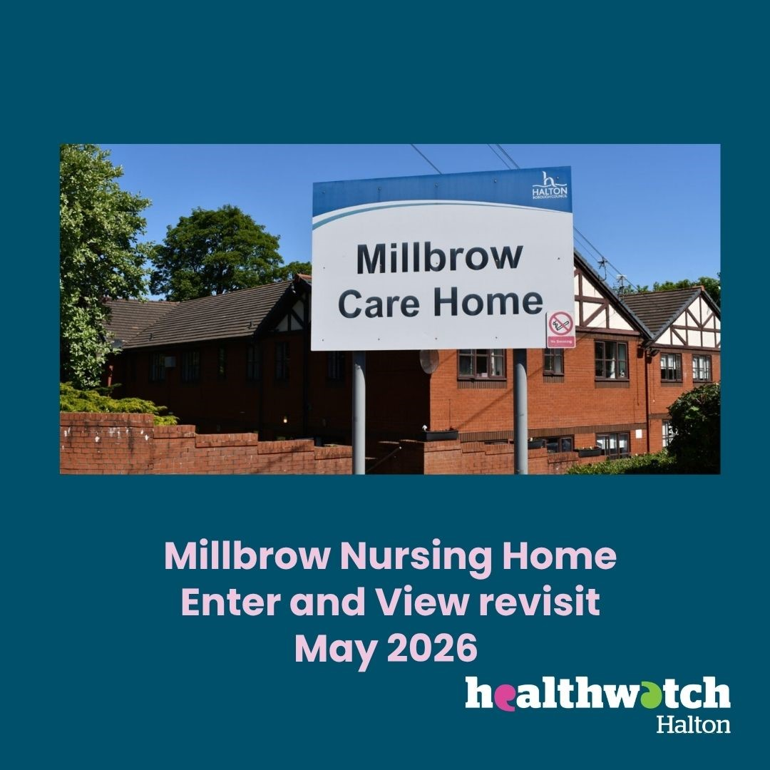
Enter and View Revisit Report
Millbrow Nursing Home
Announced visit
28th May 2026

Provider details
Details of Visit | Millbrow Nursing Home. Enter and View revisit
Registered Manager | Jayne Adamson
Service Address | Mill Brow, Widnes. WA8 6QT.
Service type | Nursing and dementia care.
Date and Time | 28th May 2026  10 am – 12 noon
Authorised Representatives undertaking the visit | Tracy Cresswell and Jude Burrows

Acknowledgements
Healthwatch Halton would like to thank the Home Manager, staff and all the residents and visitors for their cooperation during our visit.
Disclaimer
Please note that this report is related to findings and observations made during our visit on the 13th May. The report does not claim to represent the views of all service users, only those who contributed during the visit.
Who we share the report with
This report and its findings will be shared with the Manager of Millbrow care home, Care Quality Commission (CQC) and Healthwatch England. The report will also be published on the Healthwatch Halton website.
Healthwatch Halton details
Website: www.healthwatchhalton.co.uk
Telephone: 0300 777 6543
Email: enquiries@healthwatchhalton.co.uk
Purpose of the visit

The visit was an announced follow-up visit on the recommendations that were made on our initial visit in January 2024.

What we did
We revisited Millbrow nursing home, with the initial full Enter and View visit previously taking place in January 2024. The home is run by Halton Borough Council.
We arrived at the nursing home and were able to park easily in the home's car park. We rang the bell at the main entrance and were welcomed in by the manager. We were asked to sign in to the visitors' book. The manager invited us into her office. We spent time talking to the Manager and were taken on a tour of the home. The home is split across two floors. The ground floor is for nursing care and the upstairs is for dementia nursing.
The home has a recent Care Quality Commission (CQC) rating of Good. A banner promoted the care home's rating outside the home. The complaints policy is displayed on a notice board near the main entrance, as is an A4 ‘You Said We Did’ notice.
Photos of residents enjoying activities such as themed days and animal visits are displayed in the entrance foyer. There is also a remembrance tree displaying photos of residents who have passed away. The home has a garden for residents to enjoy, with a patio and grassed areas.
Hand sanitiser was available in different areas around the home.
Peelhouse Plaza is the GP for Millbrow Nursing Home and a doctor or Advanced Nurse Practitioner visits the home on Tuesday each week. The manager explained she has had some issues with hospital discharges, with documentation or red bags going missing, and will report any future occurrences to Healthwatch Halton, to raise at local trusts' Patient Experience meetings.
The manager explained that recruitment for nursing staff to the home is going well, with six nurses being taken on in the last four months. Two nursing and four care positions remain vacant. The home tried a rolling recruitment process but this attracted poor applications, so the home now advertises for specific vacancies when needed. Staff overtime and agency staff are used to cover annual leave or sickness. District nurses also visit the home.
Residents who are end-of-life families can visit at any time. They are just asked to call ahead if they will be visiting after 8 pm. The manager explained the end-of-life dignity procedures followed by the home.
Food is cooked on site with pictorial menus displayed. Although during our visit the menu was incomplete, as it did not have a date displayed or what was for dinner that day, in the downstairs dining area. The home does not have a Maintenance Officer, so it relies on council property services to do jobs in the home and garden, which can cause some delays.
The home has recently achieved its Veteran Friendly status and a plaque is displayed in the main entrance to celebrate this. Poppy symbols are put on residents' doors and care plans to show they are a veteran or a family member of a veteran. The home has three trained Veteran Champions.
Currently, two residents have no family or friends to visit them. Volunteers from a local church come in to offer them company and this brightens their day. The home is also looking into the Red Cross coming in to engage with residents.
The home takes part in regular themed days and fundraising. They have recently had speakers in for Dying Matters week and raised funds for the local mental health charity Andy’s Man Club. A summer fair is planned for August. We offered to promote fundraising or events via our social media channels.
The residents we saw on our visit seem comfortable and well cared for. Some sat in the small upstairs lounge, whilst others sat in the dining area. Another resident sat one-to-one with staff in the upstairs dining room. The manager told us that during the recent hot weather extra drinks and lollies ices have been given to residents to aid hydration.

Outcome of Recommendations made at previous visit (2024)
Recommendations made from findings
1 | Activities: Several residents and family members expressed a desire for more activities at the home. It is recommended that the home ensure there is adequate staff cover for the role of activities co-ordinator.
 | Millbrow nursing home now has a full time Activity Coordinator employed. Pictorial activity timetables were displayed in the home, with activities available on some days out of the week. The manager explained the Activity Coordinator also runs one-to-one sessions according to residents' likes, such as arts and crafts and volleyball. The Activity Coordinator also attends a Halton area network meeting for Activity staff to share ideas and good practice. The two areas of the home mix when entertainers, such as singers, visit the home.
2 | Dementia friendly: During any planned redecoration or renovations, ensure dementia friendly changes to the environment are included.
 | The home is still awaiting some refurbishment, and painted handrails and walls are in need of a refresh. Contrasting colours have not been used on some of the handrails. Laminated doors are used upstairs to give a front door appearance with a contrasting coloured front door look, with a knocker. Dementia friendly signs labelled areas such as the dining room.
3 | Communication and Information: We heard from some families who felt there was a lack of communication with them from the home. Effective communication is essential in building trust and keeping families informed and involved in the care of their loved ones. We suggest providing regular updates, scheduling face-to-face meetings, and encouraging family involvement in the home. We recommend the introduction of a ‘You said, we did’ board for all residents, and regular updates for relatives that would include any changes that have been made from comments, complaints etc.
 | Posters are displayed with information for families, such as explaining about labelling residents' laundry. A suggestion box is available in the main entrance and is checked once a month by the manager to review any ideas. A notice board with information on how to complain and a small ‘You Said We Did’ sheet are displayed in the main entrance area. We suggest having a separate, larger ‘You Said We Did’ board so residents and families can have their ideas responded to and clearly see improvements made.
4 | Involvement: Review the way Residents and Family meetings are held. While we were told that regular meetings are held, it seems that attendance is often low, while some residents told us they have not had an opportunity to be involved in these meetings. We suggest reviewing the way Residents’ meetings are promoted to try to encourage more involvement.
 | Family meetings are still poorly attended in the home and we suggest trying a less formal approach by offering a coffee morning for a cuppa and chat. The manager does offer an open door policy and families pop into the office with any questions. The manager also does daily walk arounds to chat to residents and visitors. ‘Resident of the day’ is done to focus on a particular residents with ideas sought from residents and their visitors. The home is currently working on photo boards displaying residents likes for bedroom doors, with support from families.

Provider feedback
The report highlights the improvements that have been made since your last visit and we value feedback to help us to continue to improve our services.

I would like to thank you both for coming to see us all.
In relation to point 3 – I will look at increasing the you said we did notice to a larger display that will be more easily seen.
In relation to point 4 – thank you for this suggestion of a less formal approach for relative meetings, although a lot of contact with relatives is made via managers walk arounds and having an open door policy, I will try it and hopefully more relatives / visitors will attend.
In relation to point 5 – Some staff do have the yellow name badges and I am going through the process of ordering replacements badges for any that have been lost and ones for new members of staff.
In relation to point 6 – Some toilet seats have been changed to different colours and there are plans in place to replace the other toilet seats to ensure they are dementia friendly

